Two sample test for proportions
- Hypothesis Testing:
A statistical method used to determine if there is enough evidence to reject a null hypothesis in favor of an alternative hypothesis.
- Population Proportion:
The proportion of a specific characteristic within a population, denoted as p1 and p2 for two different populations.
- P-value:
The probability of obtaining a test statistic at least as extreme as the one observed, under the assumption that the null hypothesis is true.
- Test Statistic:
A standardized value calculated from sample data during a hypothesis test, used to determine the p-value.
This content was generated by AI, so please check for any mistakes.
In the videos, you learnt how to test if the means from two populations were different from one another. In this reading item, you will see a similar test but for comparing proportions from two different populations. A common application of two sample test for proportions is in A/B testing.
An example
Imagine you want to compare the proportion of households that own a car in Chicago ($p_{1}$p, start subscript, 1, end subscript) with the proportion of households that do in New York ($p_{2}$p, start subscript, 2, end subscript). Note that $p_{1}$p, start subscript, 1, end subscript and $p_{2}$p, start subscript, 2, end subscript are population proportions.
A possible set of hypothesis for this problem is
$H_{0}:p_{1}=p_{2}\text{ vs. }H_{1}=p_{1}≠p_{2}$H, start subscript, 0, end subscript, colon, p, start subscript, 1, end subscript, equals, p, start subscript, 2, end subscript, start text, space, v, s, point, space, end text, H, start subscript, 1, end subscript, equals, p, start subscript, 1, end subscript, does not equal, p, start subscript, 2, end subscript
Consider for this test a significance level of 0.05
Suppose you randomly sample $n_{1}=100$n, start subscript, 1, end subscript, equals, 100 households from Chicago, 62 of which own a car, and $n_{2}=120$n, start subscript, 2, end subscript, equals, 120 households from New York, 58 of which own a car.
Defining $X=$X, equals"number of households that own a car in Chicago" and $Y=$Y, equals"number of households that own a car in New York: , a good approximation for $p_{1}$p, start subscript, 1, end subscriptand $p_{2}$p, start subscript, 2, end subscript are
${\hat{p}}_{1}=\frac{X}{100}{\hat{p}}_{2}=\frac{Y}{120}$p, with, hat, on top, start subscript, 1, end subscript, equals, start fraction, X, divided by, 100, end fraction, p, with, hat, on top, start subscript, 2, end subscript, equals, start fraction, Y, divided by, 120, end fraction
Naturally, a good approximation for $Δ=p_{1}-p_{2}$delta, equals, p, start subscript, 1, end subscript, minus, p, start subscript, 2, end subscript is
$\hat{Δ}={\hat{p}}_{1}-{\hat{p}}_{2}$delta, with, hat, on top, equals, p, with, hat, on top, start subscript, 1, end subscript, minus, p, with, hat, on top, start subscript, 2, end subscript
In order to get a good test statistic, you need to find the distribution of $\hat{Δ}$delta, with, hat, on top. First, note that in $n_{1}$n, start subscript, 1, end subscriptand $n_{2}$n, start subscript, 2, end subscript are big enough, which in this case they are.
${\hat{p}}_{1}=\frac{X}{100}∼N(p_{1},\frac{p_{1}(1-p_{1})}{100}){\hat{p}}_{2}=\frac{Y}{120}∼N(p_{2},\frac{p_{2}(1-p_{2})}{120})$p, with, hat, on top, start subscript, 1, end subscript, equals, start fraction, X, divided by, 100, end fraction, \sim, N, left parenthesis, p, start subscript, 1, end subscript, comma, start fraction, p, start subscript, 1, end subscript, left parenthesis, 1, minus, p, start subscript, 1, end subscript, right parenthesis, divided by, 100, end fraction, right parenthesis, p, with, hat, on top, start subscript, 2, end subscript, equals, start fraction, Y, divided by, 120, end fraction, \sim, N, left parenthesis, p, start subscript, 2, end subscript, comma, start fraction, p, start subscript, 2, end subscript, left parenthesis, 1, minus, p, start subscript, 2, end subscript, right parenthesis, divided by, 120, end fraction, right parenthesis
so that $\hat{Δ}={\hat{p}}_{1}-{\hat{p}}_{2}∼N(p_{1}-p_{2},\frac{p_{1}(1-p_{1})}{100}+\frac{p_{2}(1-p_{2})}{120})$delta, with, hat, on top, equals, p, with, hat, on top, start subscript, 1, end subscript, minus, p, with, hat, on top, start subscript, 2, end subscript, \sim, N, left parenthesis, p, start subscript, 1, end subscript, minus, p, start subscript, 2, end subscript, comma, start fraction, p, start subscript, 1, end subscript, left parenthesis, 1, minus, p, start subscript, 1, end subscript, right parenthesis, divided by, 100, end fraction, plus, start fraction, p, start subscript, 2, end subscript, left parenthesis, 1, minus, p, start subscript, 2, end subscript, right parenthesis, divided by, 120, end fraction, right parenthesis
If $H_{0}$H, start subscript, 0, end subscript is true, then $p_{1}=p_{2}=p$p, start subscript, 1, end subscript, equals, p, start subscript, 2, end subscript, equals, p. This simplifies the expression quite a bit! In this case,
$\hat{Δ}={\hat{p}}_{1}-{\hat{p}}_{2}∼N(0,\frac{p(1-p)}{100}+\frac{p(1-p)}{120})=N(0,p(1-p)(\frac{1}{100}+\frac{1}{120}))$delta, with, hat, on top, equals, p, with, hat, on top, start subscript, 1, end subscript, minus, p, with, hat, on top, start subscript, 2, end subscript, \sim, N, left parenthesis, 0, comma, start fraction, p, left parenthesis, 1, minus, p, right parenthesis, divided by, 100, end fraction, plus, start fraction, p, left parenthesis, 1, minus, p, right parenthesis, divided by, 120, end fraction, right parenthesis, equals, N, left parenthesis, 0, comma, p, left parenthesis, 1, minus, p, right parenthesis, left parenthesis, start fraction, 1, divided by, 100, end fraction, plus, start fraction, 1, divided by, 120, end fraction, right parenthesis, right parenthesis
Standardizing, you get that
$$\frac{\frac{X}{100}-\frac{Y}{120}-0}{\sqrt{p(1-p)(\frac{1}{100}+\frac{1}{120})}}∼N(0,1)$$
start fraction, start fraction, X, divided by, 100, end fraction, minus, start fraction, Y, divided by, 120, end fraction, minus, 0, divided by, square root of, p, left parenthesis, 1, minus, p, right parenthesis, left parenthesis, start fraction, 1, divided by, 100, end fraction, plus, start fraction, 1, divided by, 120, end fraction, right parenthesis, end square root, end fraction, \sim, N, left parenthesis, 0, comma, 1, right parenthesis
Unfortunately, this statistic is not good enough, because even if $H_{0}$H, start subscript, 0, end subscript is true, you do not know the value of $p$p. However, you can replace it by the aggregated sample proportion. If $H_{0}$H, start subscript, 0, end subscript is true, and $p_{1}=p_{2}=p$p, start subscript, 1, end subscript, equals, p, start subscript, 2, end subscript, equals, p, then $X∼Binomial(100,p)$X, \sim, B, i, n, o, m, i, a, l, left parenthesis, 100, comma, p, right parenthesis and $Y∼Binomial(120,p)$Y, \sim, B, i, n, o, m, i, a, l, left parenthesis, 120, comma, p, right parenthesis, so you can use both samples to get a better estimate of $p$p:
$\hat{p}=\frac{X+Y}{100+120}=\frac{X+Y}{220}$p, with, hat, on top, equals, start fraction, X, plus, Y, divided by, 100, plus, 120, end fraction, equals, start fraction, X, plus, Y, divided by, 220, end fraction
Replacing $p$p with $\hat{p}$p, with, hat, on top you finally get the test statistic
$$Z=\frac{\frac{X}{100}-\frac{Y}{120}-0}{\sqrt{\frac{(X+Y)}{220}(1-\frac{X+Y}{220})(\frac{1}{100}+\frac{1}{120})}}∼N(0,1)$$
Z, equals, start fraction, start fraction, X, divided by, 100, end fraction, minus, start fraction, Y, divided by, 120, end fraction, minus, 0, divided by, square root of, start fraction, left parenthesis, X, plus, Y, right parenthesis, divided by, 220, end fraction, left parenthesis, 1, minus, start fraction, X, plus, Y, divided by, 220, end fraction, right parenthesis, left parenthesis, start fraction, 1, divided by, 100, end fraction, plus, start fraction, 1, divided by, 120, end fraction, right parenthesis, end square root, end fraction, \sim, N, left parenthesis, 0, comma, 1, right parenthesis
To simplify the expression even further, observe that $(\frac{1}{100}+\frac{1}{120})=(\frac{100+120}{100⋅120})$left parenthesis, start fraction, 1, divided by, 100, end fraction, plus, start fraction, 1, divided by, 120, end fraction, right parenthesis, equals, left parenthesis, start fraction, 100, plus, 120, divided by, 100, dot, 120, end fraction, right parenthesis, so that you can rewrite the test statistic as
$$Z=\frac{\frac{X}{100}-\frac{Y}{120}-0}{\sqrt{(X+Y)(1-\frac{X+Y}{220})}}\sqrt{100⋅120}∼N(0,1)$$
Z, equals, start fraction, start fraction, X, divided by, 100, end fraction, minus, start fraction, Y, divided by, 120, end fraction, minus, 0, divided by, square root of, left parenthesis, X, plus, Y, right parenthesis, left parenthesis, 1, minus, start fraction, X, plus, Y, divided by, 220, end fraction, right parenthesis, end square root, end fraction, square root of, 100, dot, 120, end square root, \sim, N, left parenthesis, 0, comma, 1, right parenthesis
With the observations you have ($x=62, y=58$x, equals, 62, comma, space, y, equals, 58), the observed statistic results $z=2.0271$z, equals, 2, point, 0271. Since you are proposing a two-sided test, then the p-value is the probability that $Z>2.0271$Z, is greater than, 2, point, 0271 or $Z<-2.0271$Z, is less than, minus, 2, point, 0271:
$p\text{-value}=P(∣Z∣>2.0271)=0.04265$p, start text, negative, v, a, l, u, e, end text, equals, P, left parenthesis, vertical bar, Z, vertical bar, is greater than, 2, point, 0271, right parenthesis, equals, 0, point, 04265
Conclusion: Since the p-value is smaller than the significance level (0.05), then you reach the conclusion that you have enough evidence to reject the null hypothesis, and accept that the two population proportions are different
General Case
You have two populations or groups you want to compare.
- $p_{1}-p_{2}$p, start subscript, 1, end subscript, minus, p, start subscript, 2, end subscript, is the difference in the population proportion between two groups. (i.e. the difference in the proportion of households that own a car in Chicago and New York)
- $x$x is the observed number of individuals in the sample from the specified category from one of the groups(i.e. number households that own a car in Chicago )
- $y$y is the observed number of individuals in the sample from the specified category from one of the groups(i.e. number households that own a car in New York )
- $n_{1}$n, start subscript, 1, end subscript is the sample size for group 1 (sample size from Chicago)
- $n_{2}$n, start subscript, 2, end subscript is the sample size for group 2 (sample size from New York)
Then the test statistic is
$$Z=\frac{\frac{X}{n_{1}}-\frac{Y}{n_{2}}-0}{\sqrt{(X+Y)(1-\frac{X+Y}{n_{1}+n_{2}})}}\sqrt{n_{1}⋅n_{2}}∼N(0,1)$$
Z, equals, start fraction, start fraction, X, divided by, n, start subscript, 1, end subscript, end fraction, minus, start fraction, Y, divided by, n, start subscript, 2, end subscript, end fraction, minus, 0, divided by, square root of, left parenthesis, X, plus, Y, right parenthesis, left parenthesis, 1, minus, start fraction, X, plus, Y, divided by, n, start subscript, 1, end subscript, plus, n, start subscript, 2, end subscript, end fraction, right parenthesis, end square root, end fraction, square root of, n, start subscript, 1, end subscript, dot, n, start subscript, 2, end subscript, end square root, \sim, N, left parenthesis, 0, comma, 1, right parenthesis
and the observed statistic is $z\frac{\frac{x}{n_{1}}-\frac{y}{n_{2}}-0}{\sqrt{(x+y)(1-\frac{x+y}{n_{1}+n_{2}})}}\sqrt{n_{1}⋅n_{2}}∼N(0,1)$
z, start fraction, start fraction, x, divided by, n, start subscript, 1, end subscript, end fraction, minus, start fraction, y, divided by, n, start subscript, 2, end subscript, end fraction, minus, 0, divided by, square root of, left parenthesis, x, plus, y, right parenthesis, left parenthesis, 1, minus, start fraction, x, plus, y, divided by, n, start subscript, 1, end subscript, plus, n, start subscript, 2, end subscript, end fraction, right parenthesis, end square root, end fraction, square root of, n, start subscript, 1, end subscript, dot, n, start subscript, 2, end subscript, end square root, \sim, N, left parenthesis, 0, comma, 1, right parenthesis.
Depending on the type of hypothesis, you have different expressions for the p-value:
- Right-tailed test: $H_{0}:p_{1}-p_{2}=0\text{ vs. }H_{1}:p_{1}-p_{2}>0$H, start subscript, 0, end subscript, colon, p, start subscript, 1, end subscript, minus, p, start subscript, 2, end subscript, equals, 0, start text, space, v, s, point, space, end text, H, start subscript, 1, end subscript, colon, p, start subscript, 1, end subscript, minus, p, start subscript, 2, end subscript, is greater than, 0 : $p\text{-value}=P(Z>z)$p, start text, negative, v, a, l, u, e, end text, equals, P, left parenthesis, Z, is greater than, z, right parenthesis
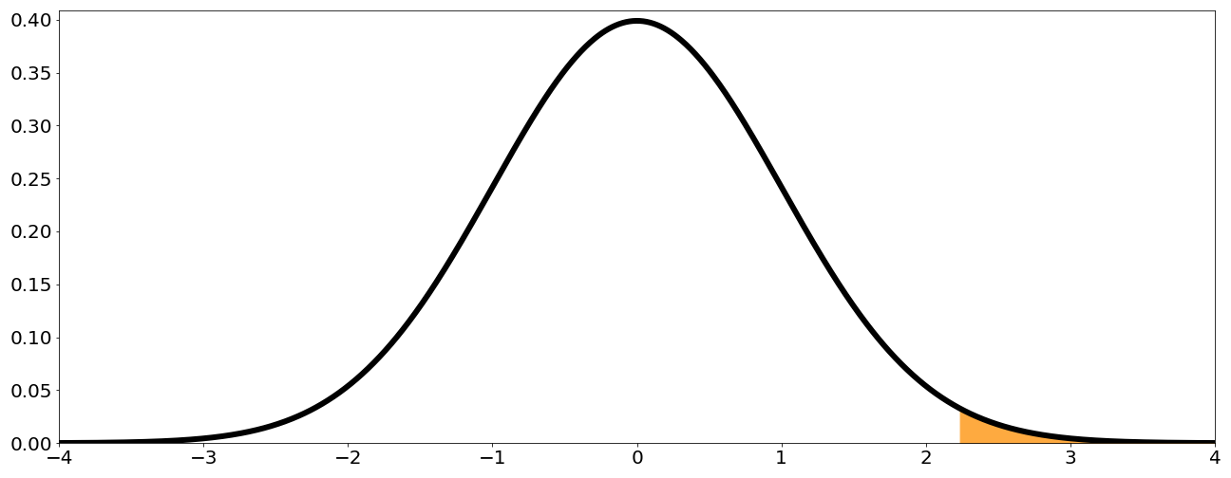
- Left-tailed test: $H_{0}:p_{1}-p_{2}=0\text{ vs. }H_{1}:p_{1}-p_{2}<0$H, start subscript, 0, end subscript, colon, p, start subscript, 1, end subscript, minus, p, start subscript, 2, end subscript, equals, 0, start text, space, v, s, point, space, end text, H, start subscript, 1, end subscript, colon, p, start subscript, 1, end subscript, minus, p, start subscript, 2, end subscript, is less than, 0 $p\text{-value}=P(Z<z)$p, start text, negative, v, a, l, u, e, end text, equals, P, left parenthesis, Z, is less than, z, right parenthesis
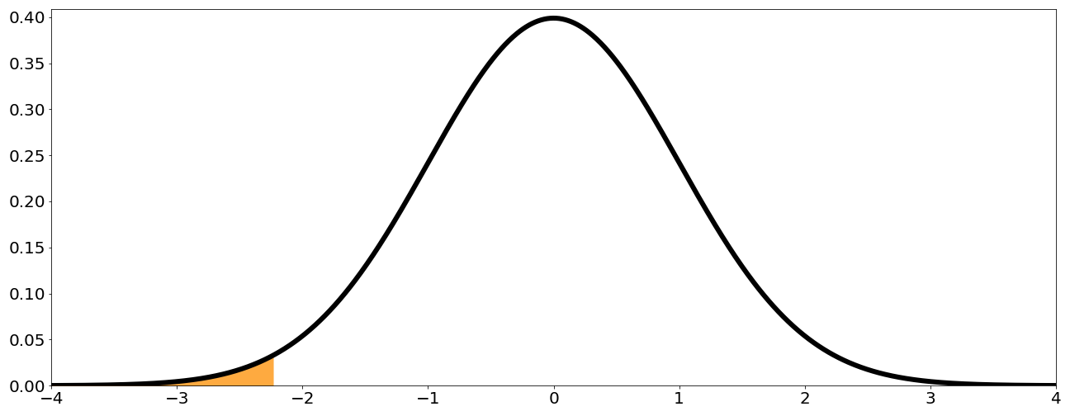
- Two-tailed test: $H_{0}:p_{1}-p_{2}=0\text{ vs. }H_{1}:p_{1}-p_{2}≠0$H, start subscript, 0, end subscript, colon, p, start subscript, 1, end subscript, minus, p, start subscript, 2, end subscript, equals, 0, start text, space, v, s, point, space, end text, H, start subscript, 1, end subscript, colon, p, start subscript, 1, end subscript, minus, p, start subscript, 2, end subscript, does not equal, 0 $p\text{-value}=P(∣Z∣>∣z∣)$p, start text, negative, v, a, l, u, e, end text, equals, P, left parenthesis, vertical bar, Z, vertical bar, is greater than, vertical bar, z, vertical bar, right parenthesis
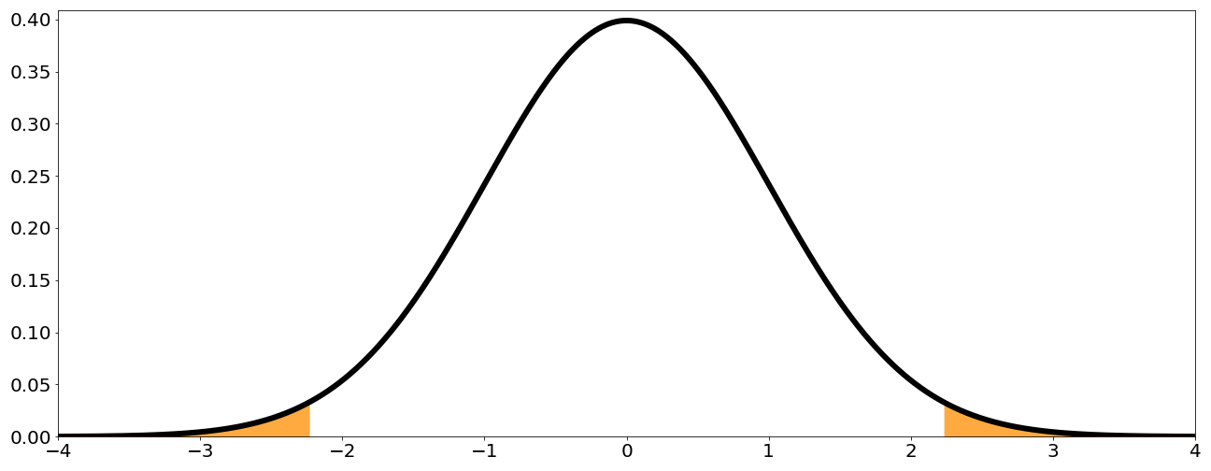
For this results to be valid, the following conditions need to be satisfied:
- There are two simple random samples that are independent from one another. This means that you have one sample from population 1, and another from population 2, and that the samples are independent between both groups.
- Each population size needs to be at least 20 times bigger than the sample size. This is necessary to ensure that all samples are independent.
- The individuals in each sample can be divided into two categories: wither they belong to the specified category or they don't
- Both sample sizes need to be at least 10. This condition needs to be verified so that the Gaussian approximation holds when the assumption that $H_{0}$H, start subscript, 0, end subscript is true.

